Overview
Welcome to the Microsoft Beta program. This service was established to allow users the opportunity to preview and test pre-release copies of Microsoft products. It also gives the product groups here at Microsoft a chance to listen to your feedback and make any necessary adjustments to their products before they go out into the real world. And finally, it gives us insight into ideas for future products.

At this time we would like to remind you that your non-disclosure agreement covers the confidentiality of all documents and software in your beta kit, as well as information concerning the entire beta process. Please refer to your non-disclosure agreement for details.

Administrative Support
For administrative support, such as if you received missing or damaged disks or need to report an address change, please call the following number: (425) 936-2382. Please have your Beta ID ready and one of our customer service representatives will assist you. Remember, this is an administrative support line only; your technical questions cannot be answered here.

Reporting Bugs
MSReport is an application that was developed to help beta sites report bugs to Microsoft. MSReport stores all system information you enter, so you only need to enter this information once, or when something in your system has changed. When submitting a report to Microsoft, the bug information you enter and any additional files are compressed in a file you can upload to transfer.microsoft.com or copy to a floppy disk and mail to the Microsoft Beta team (see address on last page). The software for MSReport is included on the disk in your kit.

Installing for the First Time

Run the Setup Program for the first time.
- Run the setup program for MSReport. NOTE: If you get the following dialog box simply press OK. Everything will work fine.

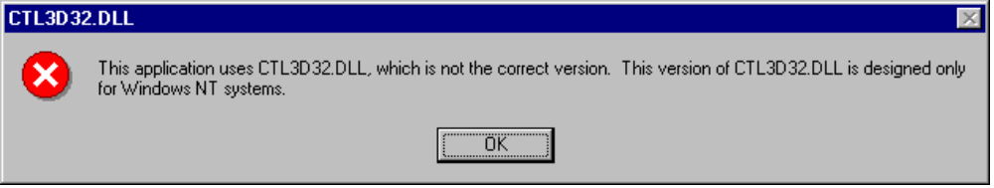
- Follow the onscreen instructions.
- You should be all setup now.

Installing over previously installed MSReport

Run the Setup Program over an existing setup of MSReport.

- Run the setup program for MSReport.
NOTE: If you get the following dialog box simply press OK. Everything will work fine.
- 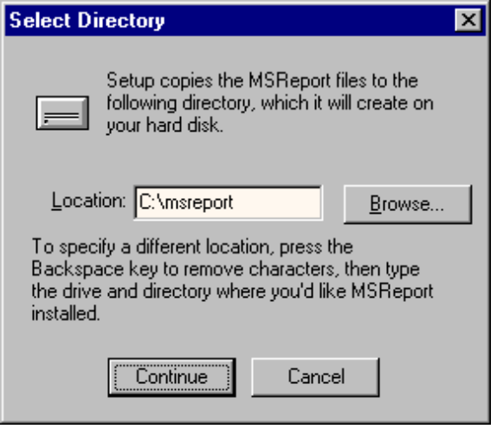In the Select Directory dialog box…
…change the location to the directory where MSReport has been previous installed on your system.
- Follow the remaining onscreen instructions.
- You should be all setup now.

Tips for Using MSReport
Getting credit for your bug report is important. It is critical that you fill out Contact Information accurately.

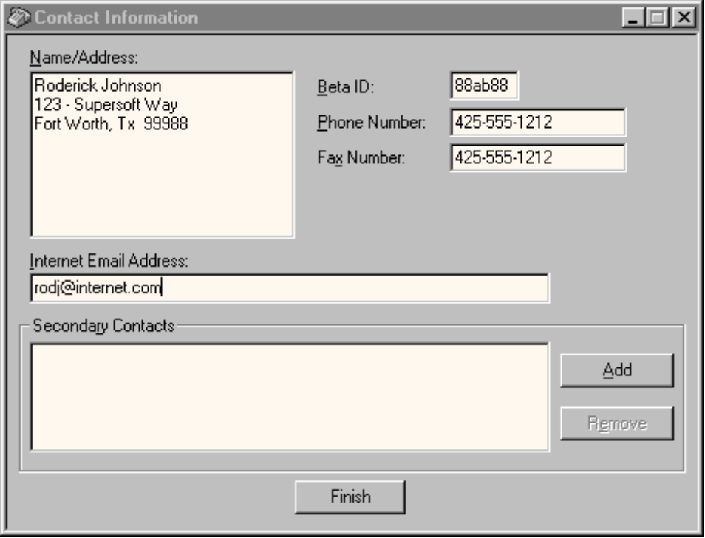

Important Notes for Contact Information Fields.
- Beta ID must be valid. Beta ID must be yours.
- Up-To-Date Phone Number. Remember to update your phone number if it changes.
- You must enter only One valid Internet Email Address. If you have sent in bug reports and do not get email confirmations that we have processed your reports you should verify you have entered only One valid email address. Two email addresses placed in the Internet Email Address field interferes with our bug confirmation mailing system.

You will only have to enter your computer configuration only once. However, if your computer configuration information changes you will need to update MSReport.

Creating a Bug Report
MSReport is a multi-beta program tool. We use a Microsoft Exchange/Outlook paradigm to create and store bug reports. This means in MSReport 1.1 you can accidentally create a bug report for the wrong beta program. Use the following procedure to get credit for your bug report.

Creating a Bug Report

- Select the correct beta program folder. For example, if you want to create a bug report against the Windows NT 4.0 beta program, you must first select the Windows NT 4.0 beta program folder from the folders on the the left side of the MSReport window.
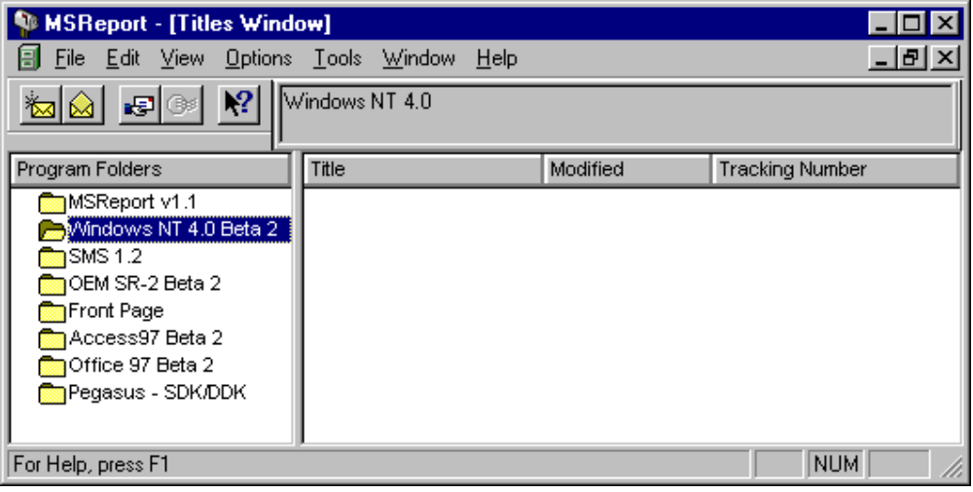

- After selecting the correct program folder, using the mouse, click the File menu and select New Report.
If you have selected the correct program folder, you will see the correct beta program name in the label in the wizard-like New Report dialog box.
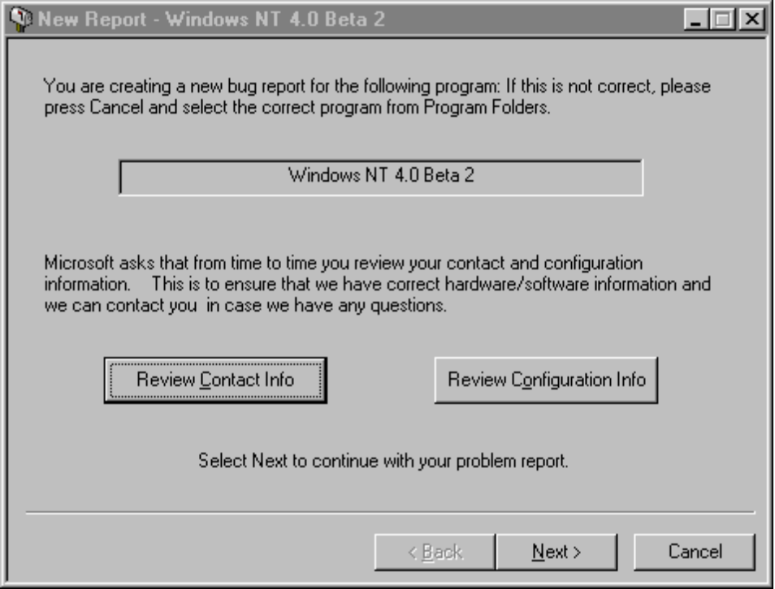
- Click the Next button to enter the details about your bug report.
- Continue through this process until Finished.
After you have saved a new bug report, you will need to create a Sendfile. A Sendfile is a compressed archive file containing one or more bug reports that you can send to Microsoft. We designed it this way so you can save time and money while uploading your bug reports.

To Create a Sendfile with multiple reports
- Using the mouse, Select the correct beta program folder.
- Select one or more bug reports from the Titles window.
- Using the mouse, click on the File menu and select Create Sendfile…
- Choose the name for the file, and click Save.

Once you have Sendfiles created you are ready to send these files to Microsoft.

Sending Bug Report Files Using FTP

You should upload your bug reports to “transfer.microsoft.com”. Please upload all bugs to the /Bupload/NT5BETA directory.

Connecting to transfer.microsoft.com

TO CONNECT TO TRANSFER.MICROSOFT.COM USING WINDOWS 95/NT FTP CLIENT FROM A MS-DOS PROMPT

- Log onto your Internet Service Provider. You can also use MSN with the Internet access.
- Start an MS-DOS box.
- Type: "ftp transfer.microsoft.com" at the C:\ prompt.
- You will be prompted for a user name. Type in the appropriate user name given to you below.
- You will be prompted for a password. Type in your password given to you below.
- User: anonymous
Password: <your_email_name>
- Type in "binary" and "prompt" in order to set the file transfer type to binary, and to turn off interactive mode. Example…
ftp> binary
200 Type set to I.
ftp> prompt
Interactive mode Off.

You are now connected.

Uploading files from transfer.microsoft.com

TO UPLOAD A BUG REPORT USING WINDOWS 95 FTP CLIENT FROM A MS-DOS PROMPT

- Connect to transfer.microsoft.com. Using the following information (See instructions above).
User: anonymous
Password: <your_email_name>
- CD to the BUpload then NT5BETA directory. For example:
- CD BUPLOAD
- CD NT5BETA
- Type in “mput <drive:\folder\filename>” on your computer. The example below assumes you are "FTP-ing" the file "report1.bug" from the "c:\bugs" folder on your hard drive.
- ftp> mput c:\bugs\report1.bug

That will commence the upload.
NOTE: You can also use a graphical program like WS_FTP™Pro at http://www.ipswitch.com/.

Downloading files from transfer.microsoft.com

TO DOWNLOAD FILES USING INTERNET EXPLORER 3.0x OR HIGHER:
- Open Internet Explorer 3.0x.
- Make the example below look like ftp://transfer.microsoft.com/bdownload/NT5BETA.

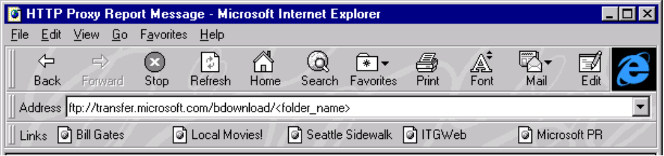
- Using the mouse, click on the file you want to download. If you have any problems contact your support group.

That will commence the download.

Submitting Problem Reports to Microsoft

Using your beta id is the preferred naming convention for reports. If you do not receive a receipt from the beta group via Internet email within two working days letting you know we received each of your reports, please upload the file(s) again.

Reporting Problems Using US Mail
You can submit your problem reports via US Mail. Please use MSReport to create a complete problem report, and mail a disk containing the MSReport bug report to:

Microsoft Corporation
ATTN – Windows NT 5.0 Beta Program 21/1
One Microsoft Way
Redmond, WA 98052-6399

